PE Funding

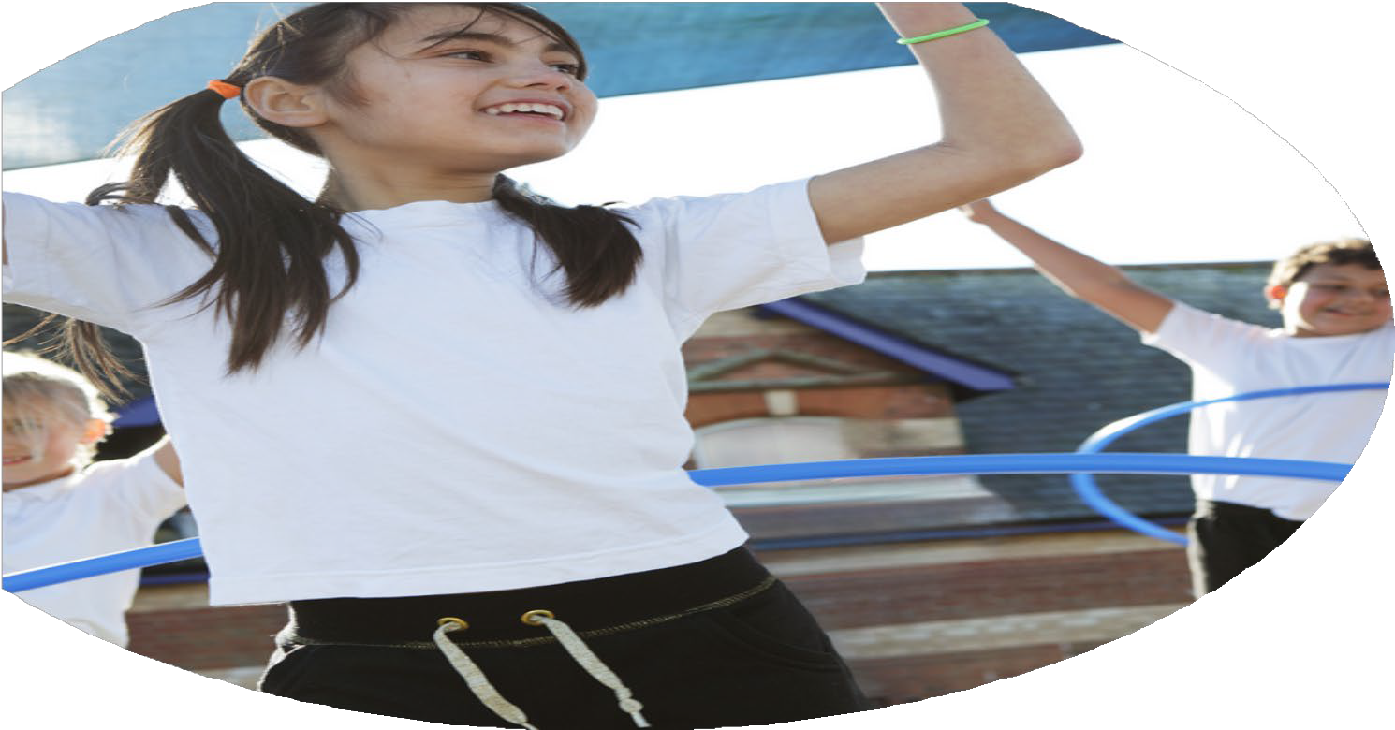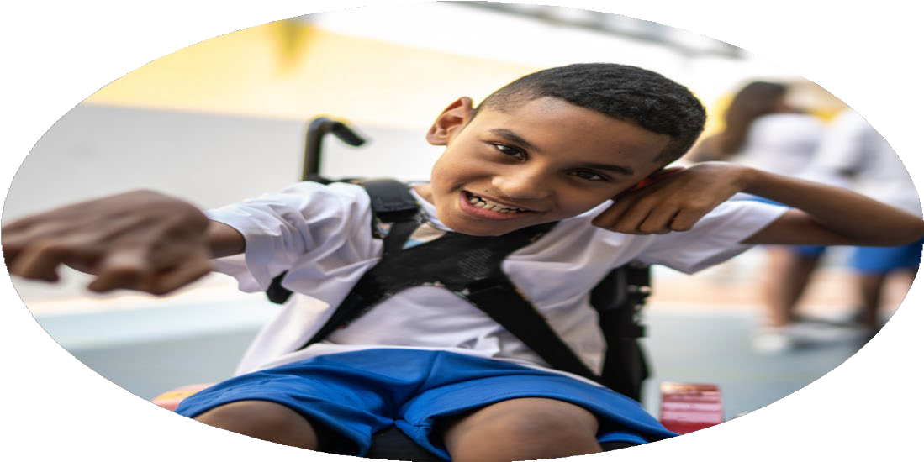

Evaluation Form

**Commissioned by**

**Created by**

Images courtesy of Youth Sport Trust

**PE Funding Evaluation Form**

 It is intended that this template should be used as preparation for the completion of the statutory digital reporting tool being introduced this academic year. You can upload data (including swimming) from this template onto this platform once it becomes accessible.

 Before you decide how you are going to use the funding for this academic year you should reflect and evaluate the impact of your use of the funding in 2023/24.

 All spending of the funding must conform with the terms outlined in the Conditions of Grant document.  The template is a working document that you can amend/update during the year.

 Based on your evaluation of last year’s funding you should decide what you intend to do this academic year, how you will do it, and what impact you expect it to have.

It is important that the funding is used effectively and based on your school’s needs.

 You must use the funding to make additional and sustainable improvements to the PE and sport in your school.  You must develop and add to the PESSPA activities that your school already offers.

*Summative digital reporting from June 2025 will continue to include swimming and water safety information therefore funding can be used to provide top-up lessons where necessary to ensure pupils meet national curriculum swimming requirements.*

**We recommend that you start by reflecting on the impact of current provision and reviewing your previous spend**

|  |  |  |  |
| --- | --- | --- | --- |
| What went well? | How do you know? | What didn’t go well? | How do you know? |
| * Targeted activities and support to involve and encourage physical activity of all pupils. * Variety of school sports clubs and activities offered. * Culture of participation in physical activity and sport. * Promotion of local sports clubs and opportunities outside of school (including school holidays). * Partnership with other schools and businesses. * Resources provided to staff to support the delivery of physical education. * Allocation of staff roles and responsibilities to support the administration, delivery and monitoring of physical activity and sport. | * High levels of participation in regular physical activity (through the curriculum and beyond). * Pupils report wide variety in the sports clubs and activities available to them. * High levels of participation in physical activity, competitive and non-competitive events and a high number of applications to take on leadership or volunteering roles that support the delivery of sport and physical activity. * Wide variety of opportunities available to children through promotion and partnership. * Staff report increased knowledge and skills in the delivery of sport and PE. | * Professional development, mentoring and appropriate training to help staff teach PE and sport more effectively to all pupils and embed physical activity across the school. * Transportation to and from sporting events/competitions. | * Consistency in quality and quantity of provision. * Availability and increased cost of transport. Cost subsidised by Sports Premium. |

|  |  |
| --- | --- |
| What are your plans for 2024/25? | How are you going to action and achieve these plans? |
| Intent | Implementation |
| * Continue to provide targeted activities and support to involve and encourage physical activity of all pupils. * Continue to offer a variety of school sports clubs and activities. * Continue to promote a culture of participation in physical activity and sport. * Continue to promotion of local sports clubs and opportunities outside of school (including school holidays). * Continue to partner with other schools and businesses * Continue to provide resources for staff to support the delivery of physical education. * Continue to allocate staff roles and responsibilities to support the administration, delivery and monitoring of physical activity and sport. * Continue to monitor and record participation levels, identifying and targeting the least active. * Provide professional development, mentoring and appropriate training to help staff teach PE and sport more effectively to all pupils and embed physical activity across the school. * Consider transportation to and from sporting events/competitions to reduce cost and increase availability. | * Continued membership of NFSSP and participation in local school events (i.e. Fordingbridge). * Continue subscription to GetSet4PE. * Continue to appoint role of responsibility and pupil advocates to promote physical activity and sport i.e. Sports Ambassadors, Road Safety Officer. * Continue to subsidise activities that promote physical activity i.e. Forest School Provision, catch up swimming lessons and sports club. * Audit staff confidence and delivery of physical education and organise appropriate training and development (including swimming). * Monitor the delivery and quality of teaching and learning in physical education. * Work in partnership with other local schools to manage transportation to and from sports events and activities. * Replace sports equipment lost through wear and tear to ensure active playtimes and lunchtime remain. |

|  |  |
| --- | --- |
| What impact/intended impact/sustainability are you  expecting? | How will you know? What **evidence** do you have or  expect to have? |
| - Regular physical activity of all pupils (through curriculum learning and beyond).  - Wide variety of sports clubs and activities available to pupils.  - High levels of participation in physical activity, competitive and non-competitive events  - Variety of school sports clubs and activities offered.  - Culture of participation in physical activity and sport.  - High quality teaching and learning of physical activity. | -High levels of participation in regular physical activity and sport evidence through monitoring.  -Pupils will report variety in the sports clubs and activities available to them.  - High number of applications to take on leadership or volunteering roles that support the delivery of sport and physical activity.  -Consistency in quantity and quality of provision. |

|  |  |
| --- | --- |
| What **impact/sustainability** have you seen? | What **evidence** do you have? |
|  |  |